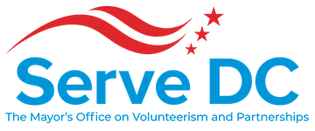

DC Commission on National and Community Service
2000 14th Street NW | Suite 101 | Washington, DC 20009 | 10.10.19 | 6:00 PM
Please join my meeting from your computer, tablet or smartphone.
https://global.gotomeeting.com/join/523680101
You can also dial in using your phone.
United States: +1 (872) 240-3212 Access Code: 523-680-101
New to GoToMeeting? Get the app now and be ready when your first meeting starts:
https://global.gotomeeting.com/install/523680101

AGENDA
- Call to Order - Brandon Andrews, Chair
- Roll Call - LaVita Anthony, Executive Assistant
- Approval of the Minutes
- Chair’s Opening Remarks - Brandon Andrews, Chair
- Director’s Report & Remarks – Ayris T. Scales, Chief Service Officer
- Programs
  - AmeriCorps - Jenny Kessler, National Service Officer
    - Vote: FY19/20 AmeriCorps Competitive Grant Applications
    - Service Year Alliance
    - All Corps Member Conference
  - Emergency Preparedness - Anthony V. Stevens, Director Volunteer & Donations Management
  - Volunteerism & Partnerships - Ayris T. Scales, Chief Service Officer
- Commissioner Updates
  - Serve DC Commissioner Subcommittees - Brandon Andrews, Chair
- Discussion
  - FY20 Goals & What Does Commissioner Engagement Truly Look Like– Brandon Andrews, Chair & Ayris T. Scales, Chief Service Officer
- Announcements (Commissioners Roundtable)
- Adjourn
2020 Meetings: March, June, September, December

